Livestock News Issue 2
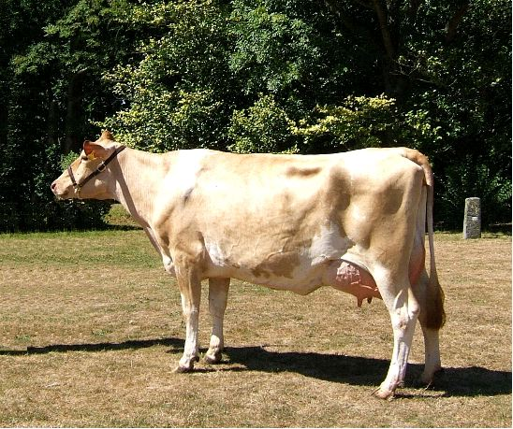

From Farm Services
farmservices@commerce.gov.gg
Telephone: 234567
Ansaphone: 235740

Content by: Caroline Creed, Farm Services Manager
David Chamberlain, States Veterinary Officer
The purpose of these electronic newsletters is to keep farmers and livestock keepers reminded of their obligations and informed of any issues which may relate to them. In addition to our dairy and beef keepers, these newsletters will now also be sent to goat, sheep and pig keepers. Obviously not all the content will apply to you but we shall try and make this clear where possible.

DAIRY FARMERS: Beef Semen
We currently have Belgian Blue, Hereford, Aberdeen Angus and Charolais beef semen available. Other beef breeds from an approved list can be ordered in as private stock.

DAIRY FARMERS: Isolation Facilities
A recent event has highlighted the need for all farmers to have adequate 'isolation' facilities. In circumstances when an animal is suspected of having a notifiable disease the farmer may be directed to the SVO to place the animal into isolation under the powers of the Animal Health Ordinance 1996. It may not be appropriate for the animal to be destroyed immediately so isolation facilities must be available.

DAIRY FARMERS: Fattening of Cull Cows
This is a useful extract of a paper from from the University of Hungary.
Dairy cows are disposed of because of poor production or animal health reasons. The culling usually takes place at the end of lactation, and thus they are in general in poor condition. These animals can be sold for slaughtering only after proper conditioning. This shall be started as early as the last trimester of the lactation, until the animals are producing milk, so the efficiency of building reserves is better, and the conditioning is cheaper. Some cows which are open for a long time show extremely good condition, and there is no need for fattening.
When upgrading, the energy requirement for maintenance and the actual milk production is increased by up to 20%. Higher energy supply will only increase the amount of abdominal tallow. The cows should get the surplus energy by consuming more forage. The concentrate quantity should be 1-2 kg more, than that the animals milk production would justify.
When the upgrade fattening begins after lactation, it more forages should be fed, and the amount of concentrate should not exceed 2.5 -3.0 kg per day. The result of the upgrading is that fat deposits among the muscles fibres, while the animals weight increases by 100-130 kg. Accordingly, animals may be sold on a higher price.

ALL LIVESTOCK KEEPERS: Castration of Livestock
You are reminded you must be licensed by the Department to undertake any form of castration of livestock. Those who are already authorised must apply to Farm Services annually to have their authority renewed.

ALL LIVESTOCK KEEPERS: Blue Tongue Virus Vaccination
Following the blue tongue virus (BTV) outbreak in France at the end of last summer we have been preparing for a possible incursion of the virus carrying midges into the Channel Islands this year. It is anticipated that in south east England 30% to 50% of livestock keepers will be voluntarily vaccinating their stock when vaccines are available later in June. Indications are that if the Channel Islands become infected the second year or infection will be worse than the first.
We have previously sent out requests for interest in vaccination and uptake has been low so far. The consequences of infection will vary for cloven hooved livestock because the severity of disease varies between the species; sheep being worse affected then cattle then goats. Infection will also have consequences for potential exports of live animals so if you anticipate that you may want to export livestock it would be wise to vaccinate them before they become infected.
There is likely to be a scramble for vaccine once it is released in June and we are attempting to secure a supply for those who want to vaccinate their livestock. If you anticipate that you will want to vaccinate then tell us now. The identification of all vaccinated animals must be recorded and shared with us to help us differentiate between animals which were vaccinated and those who were infected.

ALL LIVESTOCK KEEPERS: Deliveries to Abattoir
Farmers delivering consignments to the abattoir are still struggling to get an appropriate amount of bedding in the trailers. It's either far too much or none. They must find a balance and provide just enough to provide some grip and to soak any urine and faeces passed during the journey.
PLEASE DO NOT HESITATE TO CONTACT FARM SERVICES FOR ADVICE / INFORMATION ON LIVESTOCK MATTERS.

